Faculty Research, Scholarship, and Creativity Grant

Overview

The College invites proposals from the faculty for research, scholarship, and creativity grants. The primary purpose of the grant is to support faculty research, scholarship, and creative activity; and, proposals should reflect that focus.

Faculty Research, Scholarship, and Creativity Grants are funded by the Provost’s Office, and administered by the Research, Scholarship, and Creativity Committee.

Funding Limits and Availability of Funds

Faculty may receive a maximum of $2,500 in any single 12-month period. Faculty who receive a grant for more than $1,500 are ineligible for further grants of more than $1,500 for three years. Those who receive a grant of $1,500 or less may apply again for any size grant 12 months from the date of their award. Funds become available immediately upon approval of a proposal, and must be spent within the next 12 months. Funds are disbursed upon submission of receipts for approved expenses. Applications are intended for future RSC expenditures OR for expenditures since the end of the last grant window for faculty grant applications (typically October and March deadlines). This includes RSC-related workshop or tuition expenses (see below).

Eligible Expenses

Grant funds may be used for the following expenses if justified in the grant proposal:
- Research-related expenses, including materials, equipment, travel, or fees for outside services,
- Tuition for coursework to enhance research, scholarship, and creative activity. (Note: travel expenses related to coursework may be covered if justified in the proposal. Limit on travel expenses is $250.00, and tuition plus travel expenses cannot exceed established limits for awards.)

Items not Eligible for Funding

- Activities that do not have as the primary purpose the support of the faculty member’s own research, scholarship and creative activity
- J-term scouting trips
- Faculty supplemental salary
- Travel to conferences or professional meetings
- Personal computers and technical equipment if comparable equipment is available elsewhere on campus or could be provided by LIS

Summary Report

Grant recipients are required to submit a summary report no later than 13 months following their award. An outline for the report will be provided by the RSC Committee when the grant is awarded. Faculty must submit a summary report from any previous awards before being eligible to apply in subsequent years.

In addition to the summary report, grant recipients are expected to provide a short (~5 minutes) video presentation. The applicant’s preferred format of presentation (e.g. voice-over PowerPoint, Google Meet recording, etc.) is acceptable.

Selection Criteria

The committee will review proposals, evaluate, and rank them based on the criteria below:
- Applicant must be a full-time member of the faculty (tenured, tenure-track, contract) so that the impact will have a greater long-term influence on the campus.
- The proposal should clearly present how this project will have an impact on the faculty member’s scholarship or creative activity.
- New research projects, particularly those that may attract external funding will be given higher priority than projects that were previously funded by the program.
- Priority will be given to projects that cannot be funded through other budgets at Carthage and to projects that demonstrate an attempt to attract external funding.
- Faculty must submit summary reports from previous awards before being eligible for subsequent funding.

Members of the Committee who submit grant applications will need to recuse themselves from the selection process.

Submission and Review Process

To apply for a Faculty Research, Scholarship, and Creativity Grant, use the following proposal form, keeping in mind the selection criteria outlined above.

Proposals will be reviewed by the Research, Scholarship, & Creativity Committee two times per year, with the first review occurring at the committee’s October meeting, and the second at the March meeting.

Proposals may be submitted at any time (rolling submission) for consideration at the next review date. To ensure consideration, proposals should be submitted one week prior to the October or March committee meeting dates. Proposals that are not funded can be revised and resubmitted for the next scheduled review. Completed proposal forms should be e-mailed as an attachment to the Research, Scholarship, & Creativity Committee at rscc@carthage.edu. If possible, please include all application materials as a single PDF document.
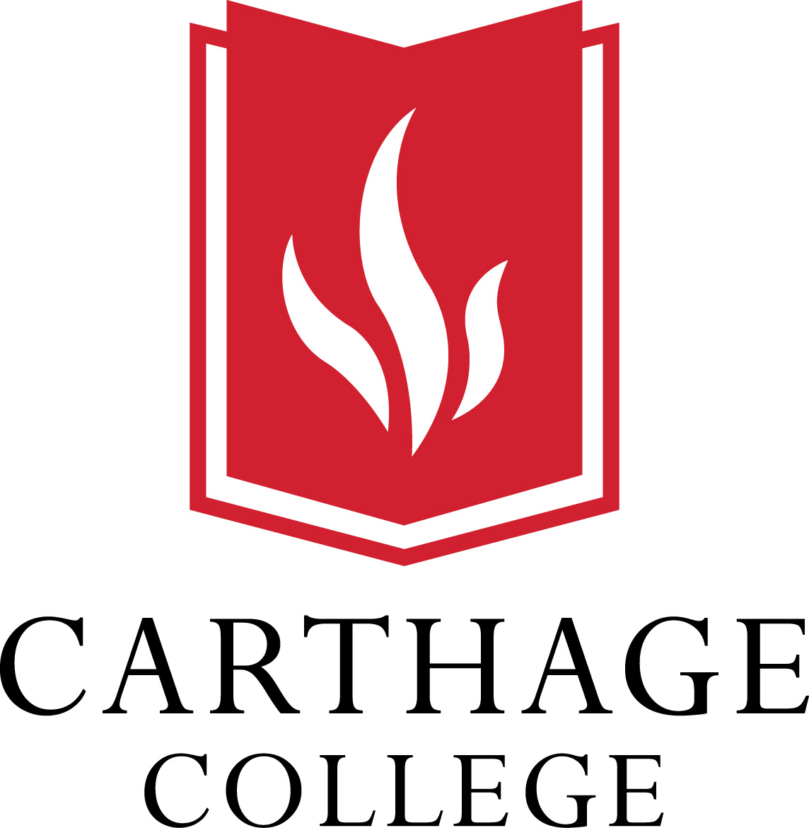

Faculty Research, Scholarship, and Creativity Grant

Please enter responses in white boxes below each question/section below.
Proposal Title
Applicant Name
Application Date
Grant Amount Requested ($500.00 - $2,500.00)
Objective of the Project and Its Significance (including expected outcomes and dissemination)
Project Benefits to the Faculty Member, College Community, and Beyond the Carthage Community
Procedure and/or Activities Constituting the Project
Detailed Budget Estimate and Rationale for not Seeking External Funds or Support Elsewhere at Carthage for the Requested Amounts
Projected Dates in which Funds will be Spent
Does your research involve human subjects? If so, indicate whether you (a)
have received IRB approval; (b) have applied for IRB approval; or (c) plan to
submit for IRB approval (indicate when you will submit).
Years of Previous Grant Awards and Confirmation that Reports were
Submitted (Please attach any outstanding reports)
Other Considerations: Outside grants applied for and won by applicant,
student involvement, etc.
A Current Curriculum Vitae (Please attach)

